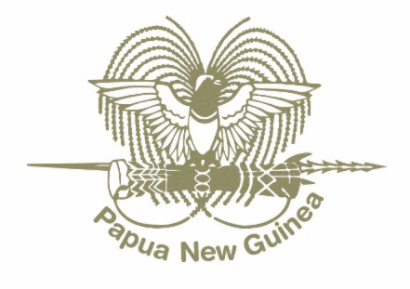

**PRESS STATEMENT**

July 18, 2023

**“Papua New Guinea and Estonia to work towards Country-to-Country Level for the implementation of MTDP Strategic Priority Area 8: Digital Government”**

The Minister for Finance and Planning, Hon. Rainbo Paita MP had bilateral meeting with the Estonian Ambassador and Permanent Representative to the United Nation, H.E Rein Tammsaar at the margin the United Nations High-Level Political Forum on Sustainable Development in New York, USA.

At the bilateral meeting, the Hon. Rainbo Paita MP expressed Papua New Guinea (PNG) desire to seek a country-to-country level strategic alliance with the Republic of Estonia for the development of Papua New Guinea’s Digital Government initiative as part of the delivery of PNG Government's Medium-Term Development Plan IV 2023-2027.

The Hon. Rainbo Paita MP reaffirmed that PNG is committed to embracing the future of governance, where technology and digital solutions are intertwined with the everyday functioning of our government and public service. This has been reflected well through Governments recent Policy interventions including the Digital Transformation Policy 2020 and the Digital Government Act 2022”.

“To ensure we chart this new course correctly, we need to collaborate with global leaders in the field of digital governance. Estonia, being the world's most advanced digital government, is the ideal partner for this crucial endeavour” said Hon. Rainbo Paita. MP.

I am really happy with the outcome of our meeting because this strategic partnership will mark the start of an ambitious development program to build a digital government for PNG, modelled after Estonia's successful digital cluster approach.

By learning from Estonia’s experience and leveraging their expertise, we aim to foster a system of governance in PNG that is transparent, accountable, and highly efficient.

We agreed that a small team from PNG, including representatives from the Department of Planning, National Procurement Commission, Internal Revenue Commission, Department of ICT, Department of Finance, and the Department of the Prime Minister & National Executive Council, will visit Estonia on September 6th, 2023 to initiate a meaningful dialogue, engage in knowledge exchange, and discuss a bilateral cooperation with the Government of Estonia and its ICT cluster members.

“This cooperative journey will be a landmark in PNG's transformation towards becoming a digitally advanced nation. This strategic partnership is not merely about importing a model; rather, it's about tailoring a digital government framework that caters to the unique needs and aspirations of the people of Papua New Guinea, said Hon. Rainbo Paita MP”.

Hon. Rainbo Paita MP further expressed our profound gratitude to the Republic of Estonia for their readiness to share their digital governance journey and experiences. This venture underlines our shared commitment to innovation, better governance, and the betterment of the lives of our citizens.

The Marape-Rosso Government is committed towards working with strategic alliances in the ICT space to shaping an exciting digital future for Papua New Guinea, ensuring a modern, accessible, and effective public service system for our people.

**HON. RAINBO PAITA, MP**

Minister for Finance and Planning